- create user with name Techie and provide sudo access to user.
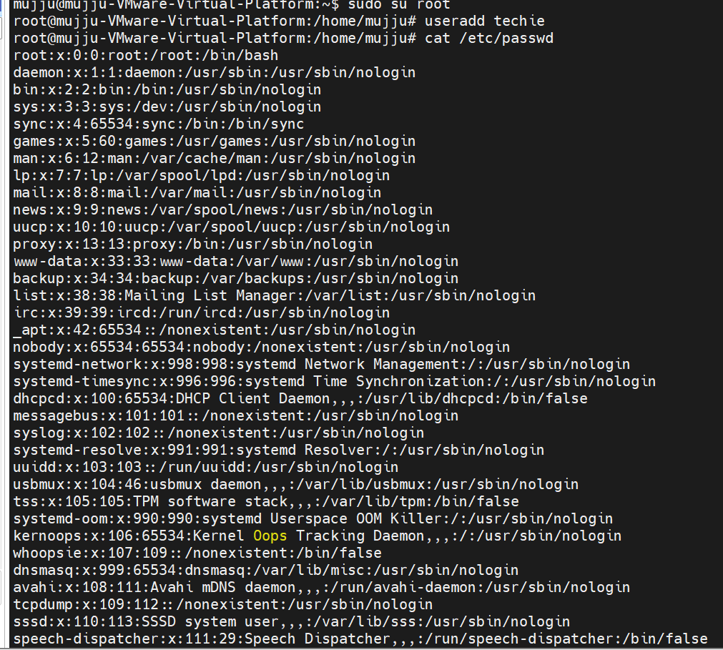
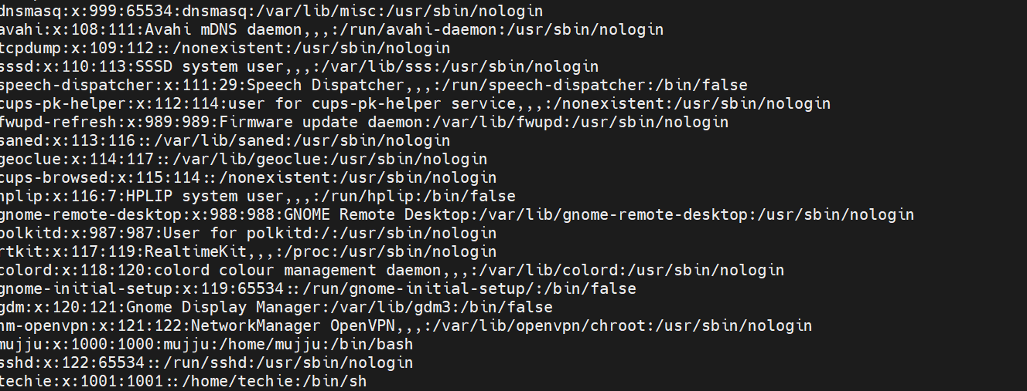

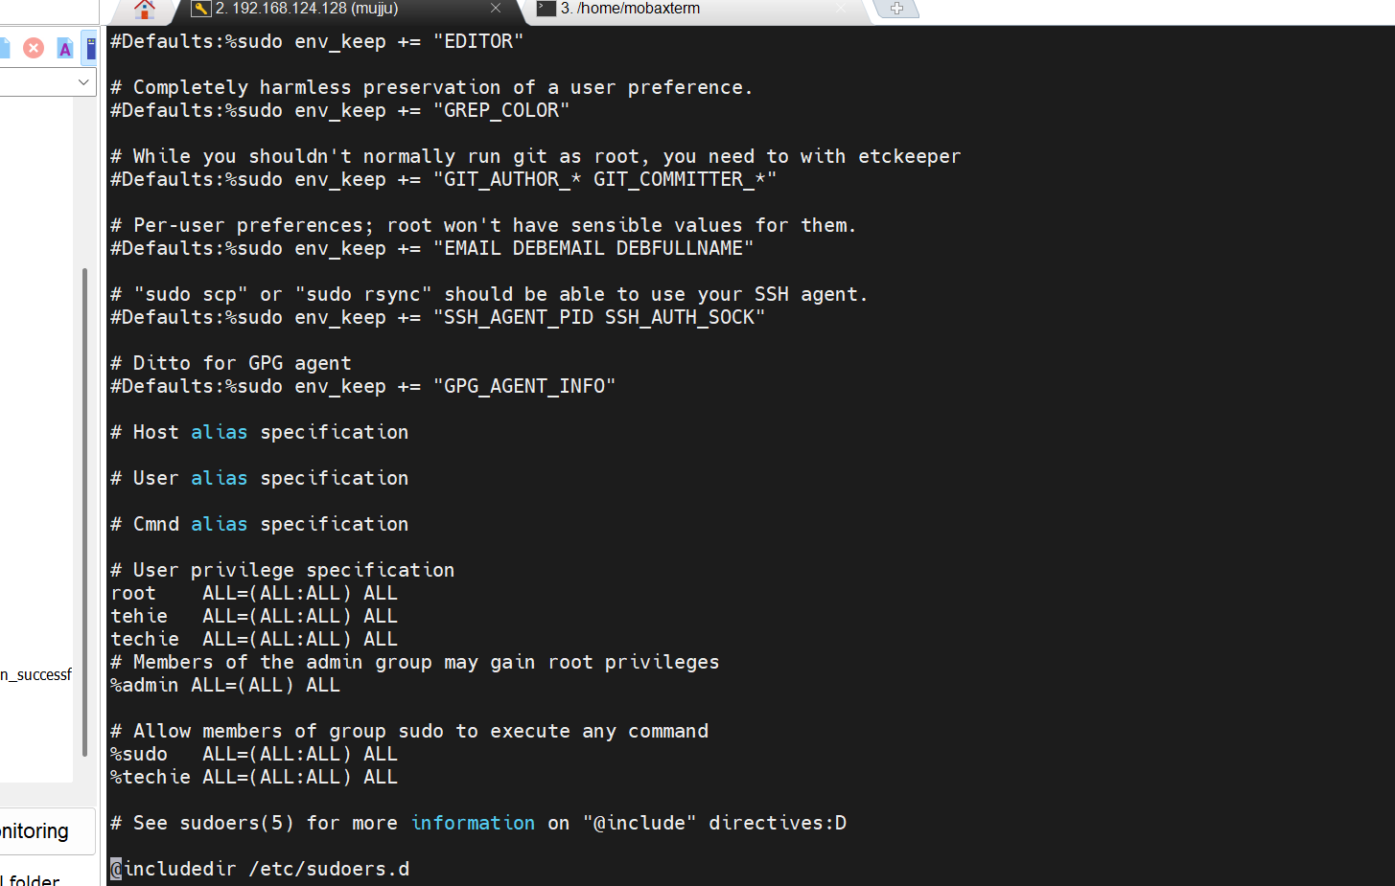

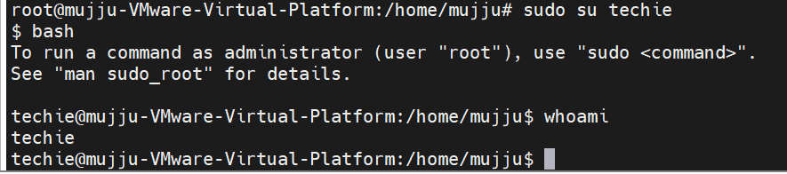

- Navigate to the home directory.
- Create a new directory.
- List the contents of a directory
- Change the current directory.
- Create a new empty file
- View the contents of a file
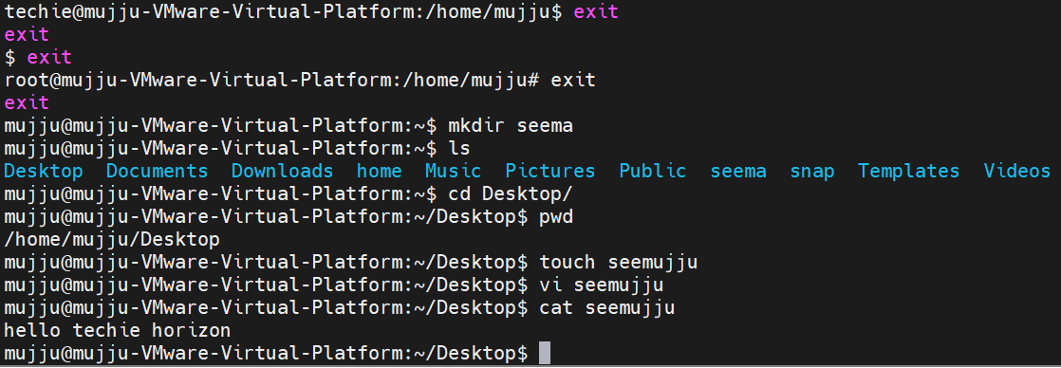

- Copy a file to another location

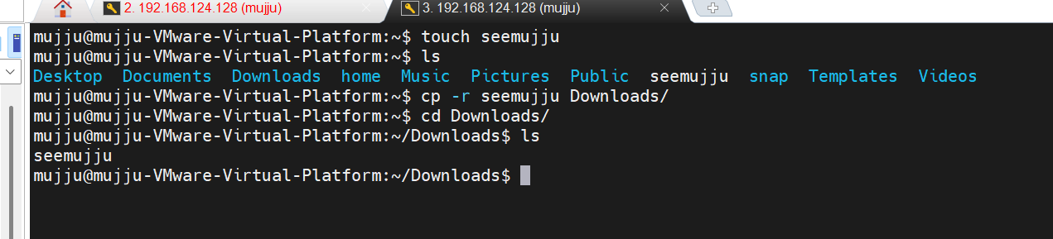

- Move a file to another location.

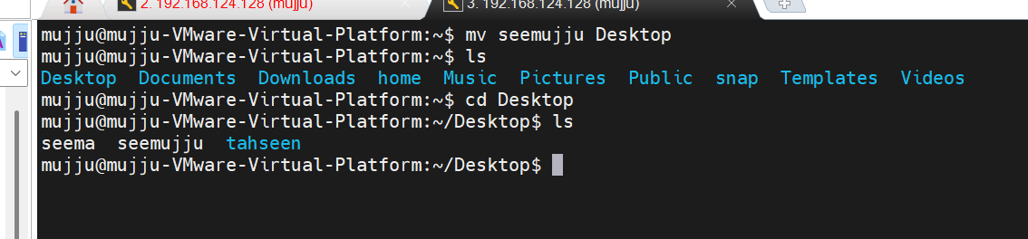

- Rename a file.

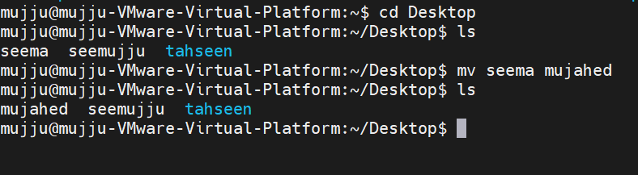

- Delete a file

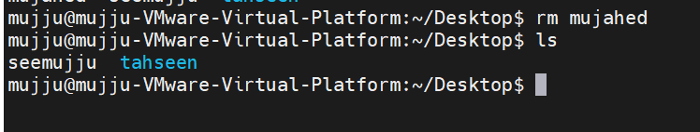

- Grant or revoke permissions on a file or directory
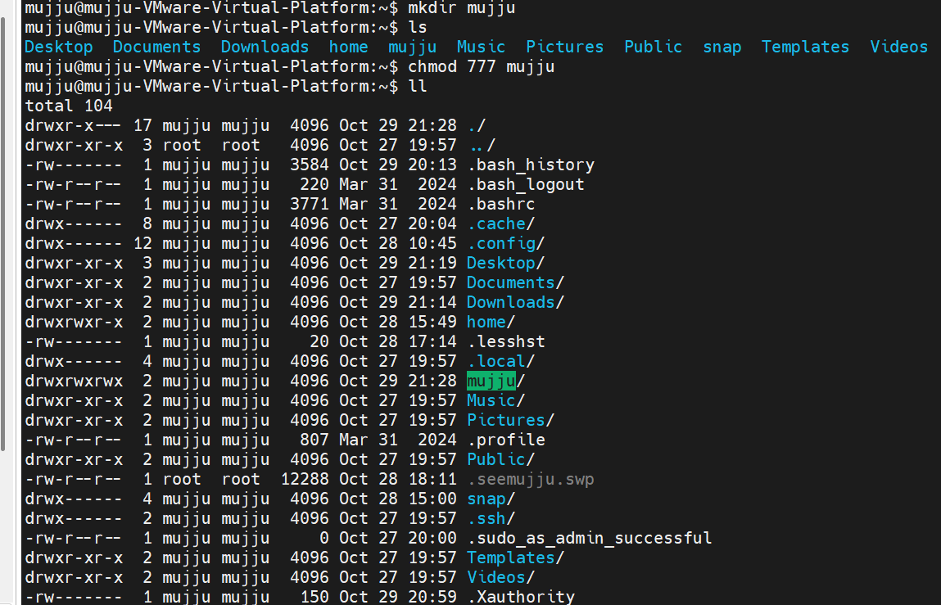

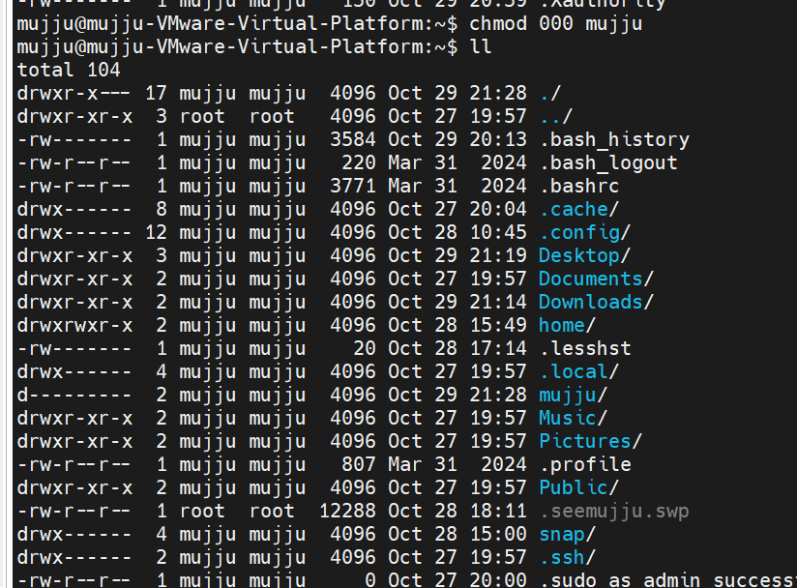

- View the current date and time


- Check the system uptime
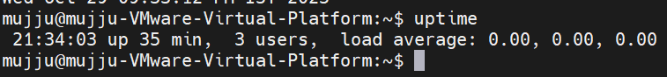

- View the running processes.

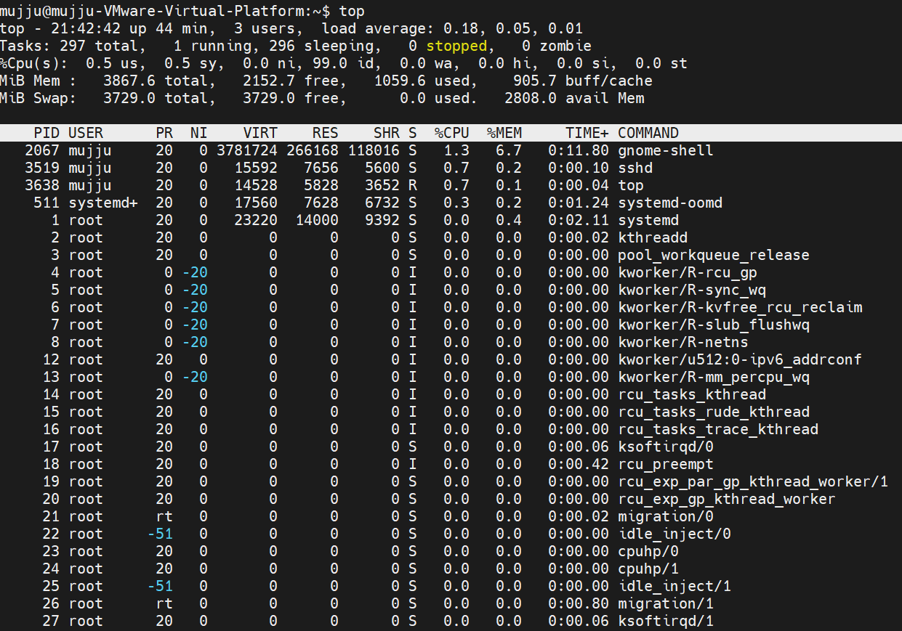

- Kill a running process.
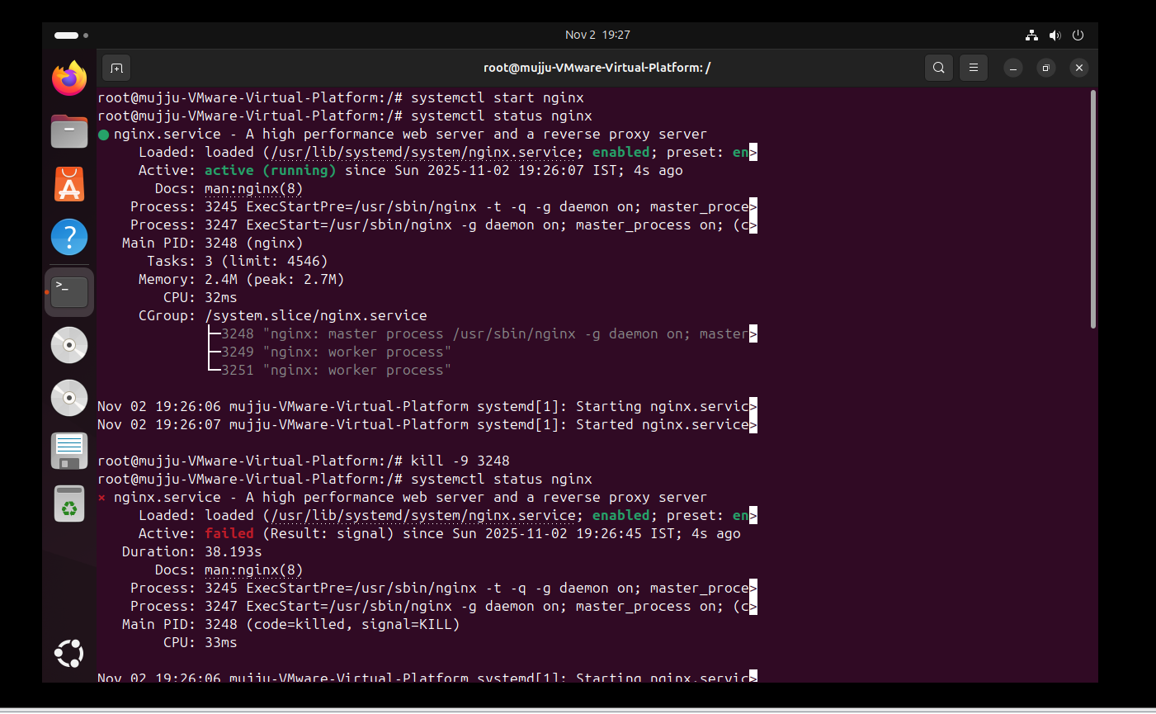
- Install a package using the package manager (e.g., apt or yum).

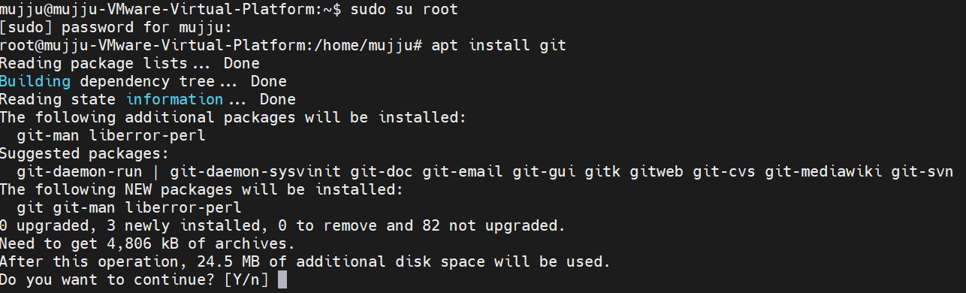

- Update the system packages

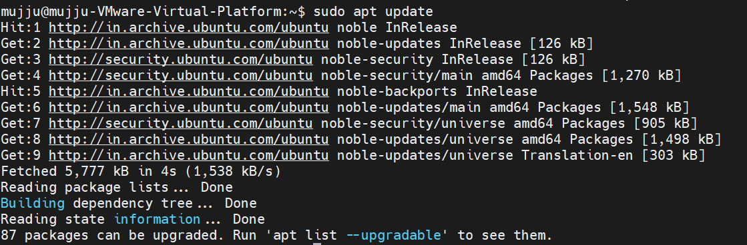

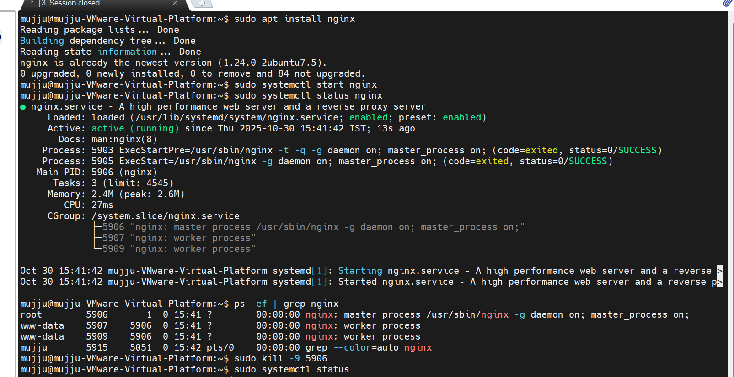

- Create a symbolic link
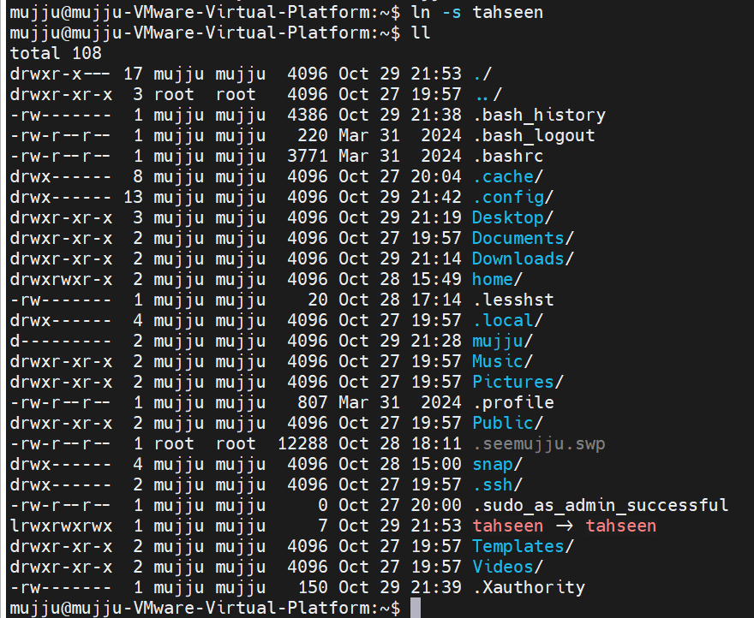

- Search for files using the find command

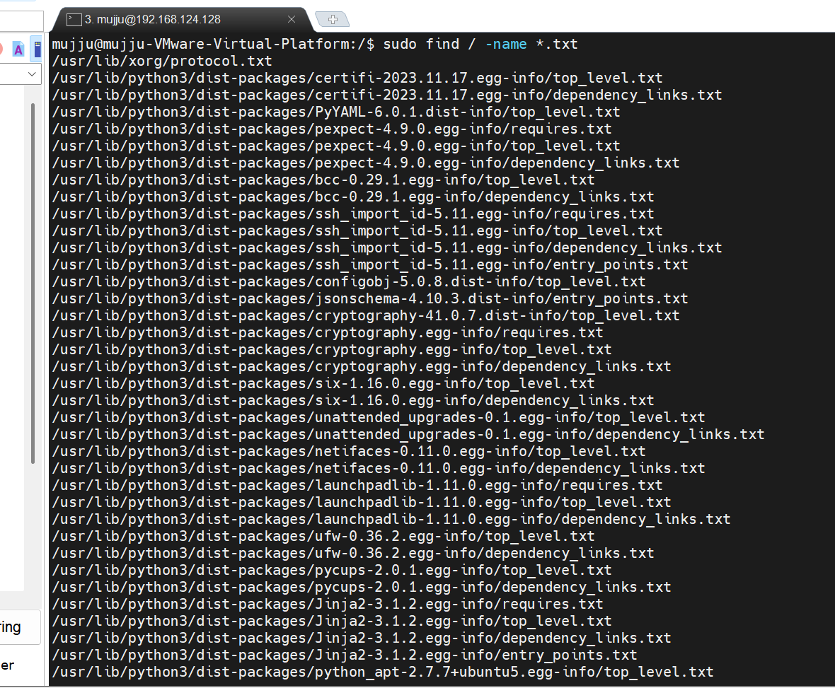

- Compress and decompress files using tar

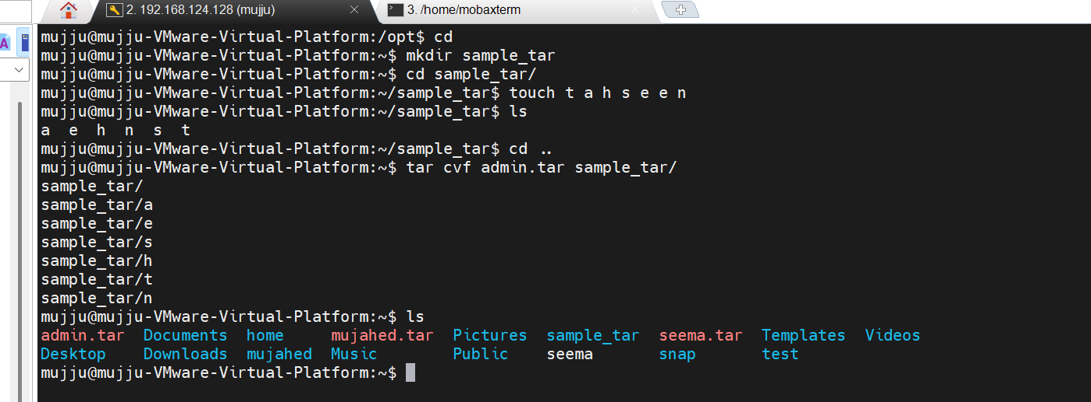
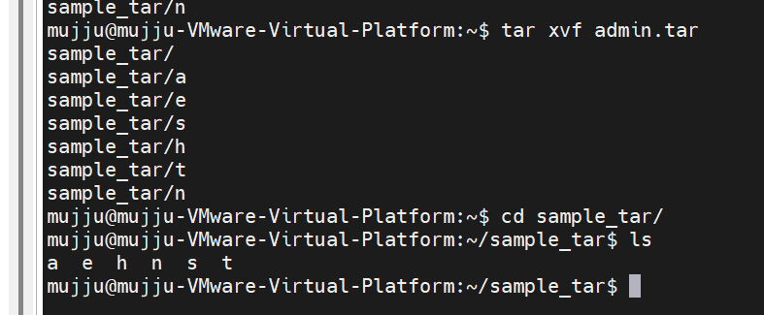

- Monitor system resources with top or htop
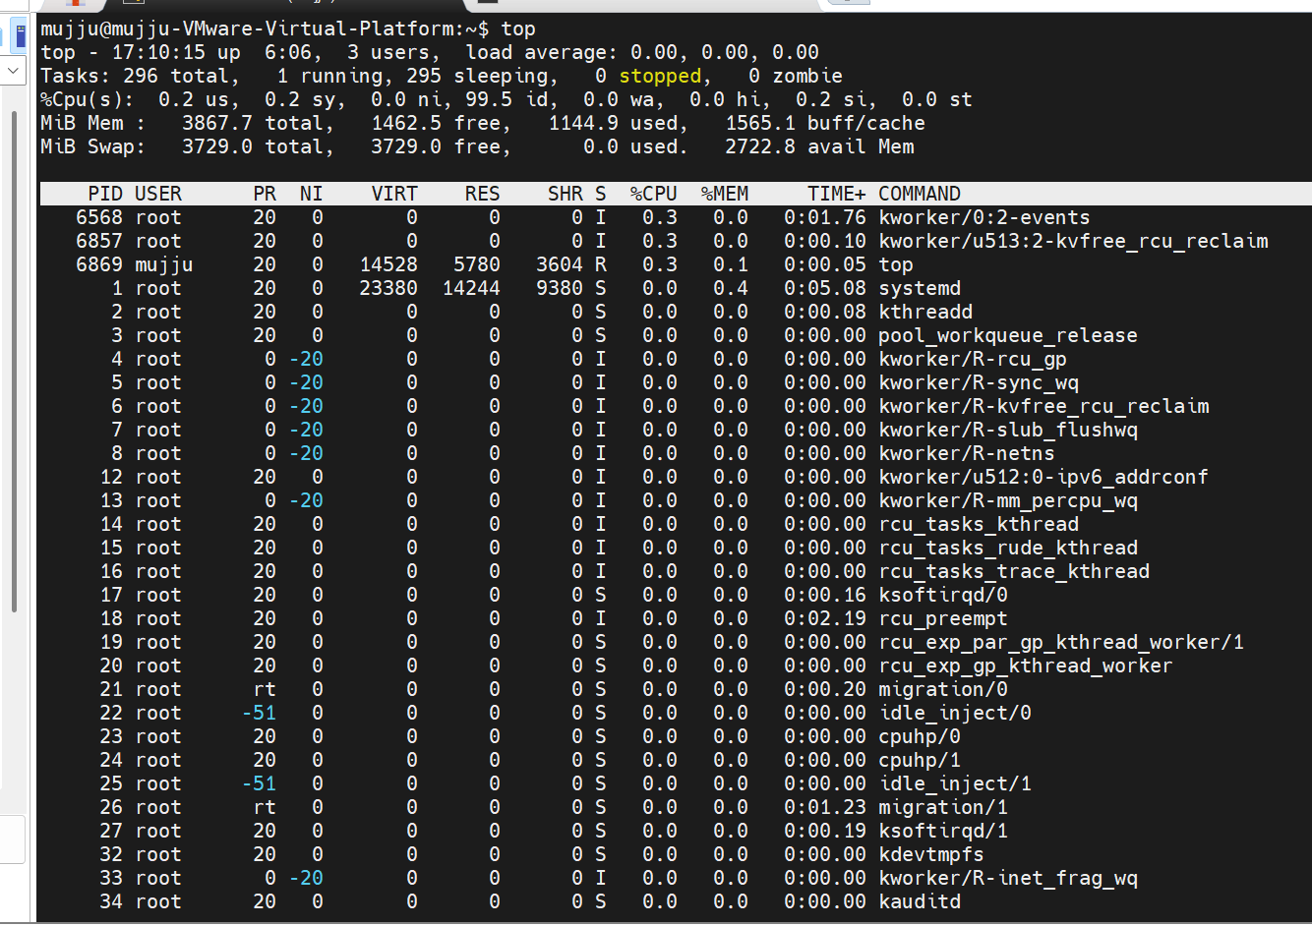
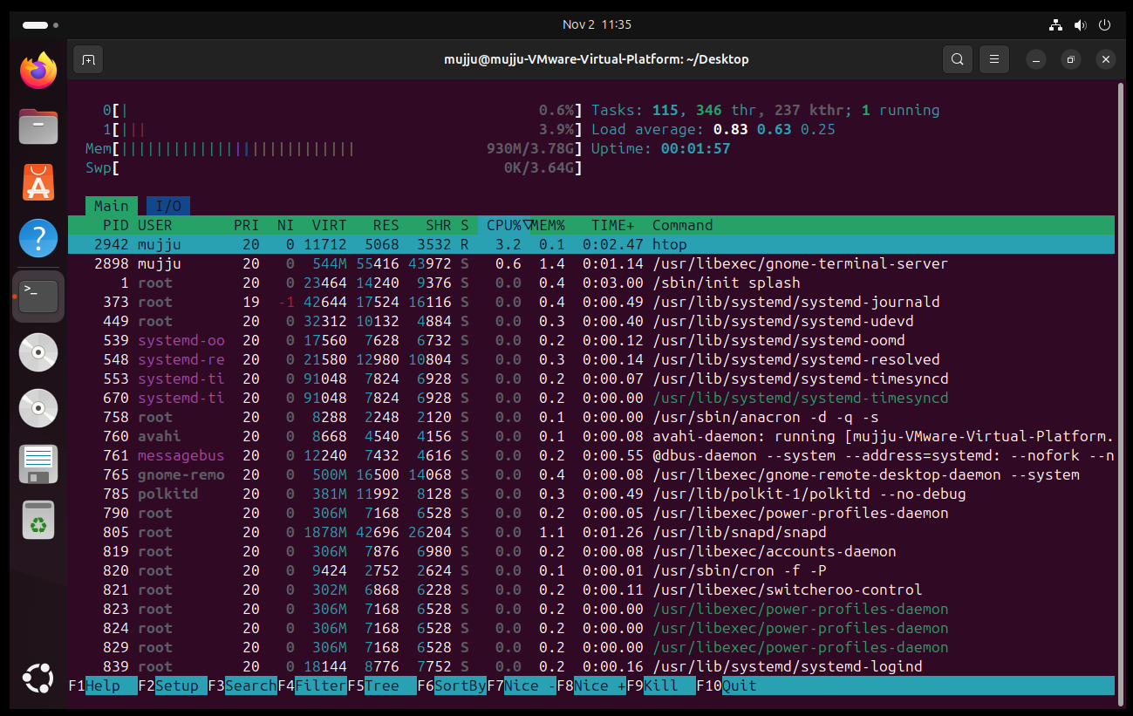

- Create and manage user groups

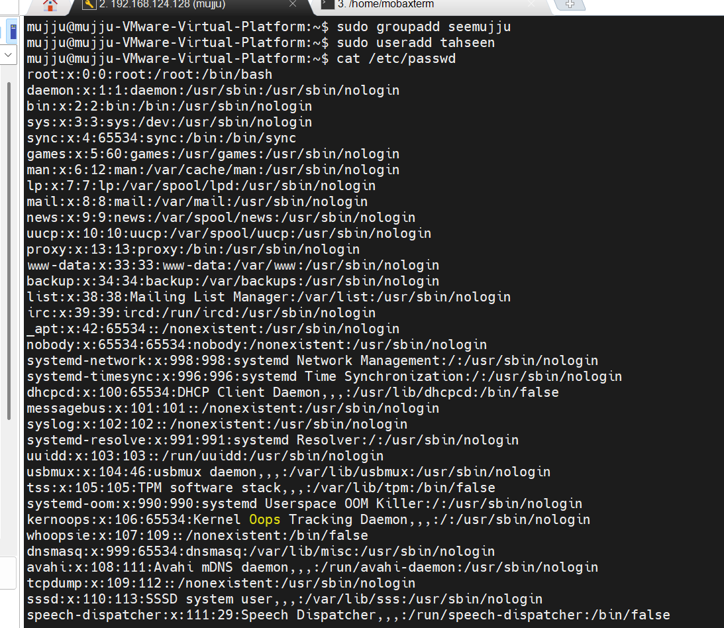
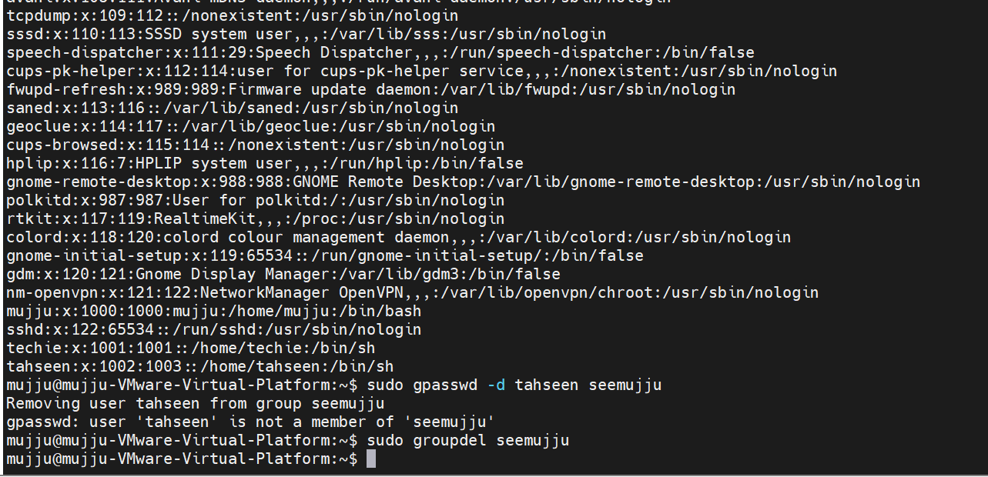

- Set up SSH password less authentication
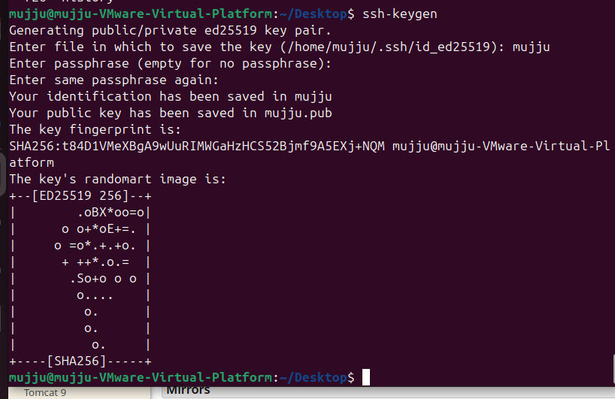

- Monitor log files using tail or grep
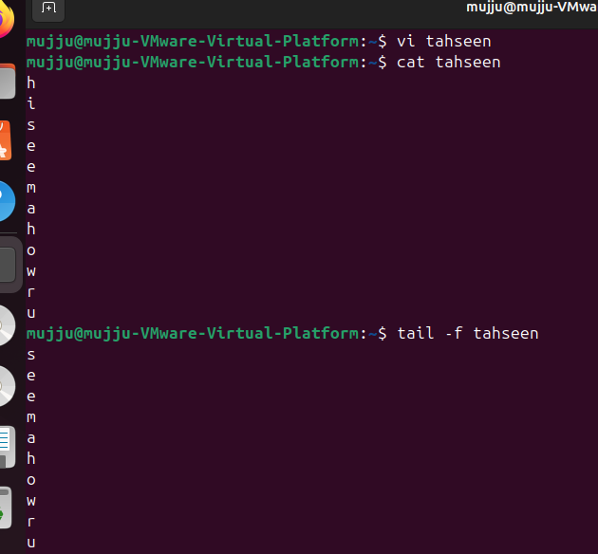

- Set up a web server (e.g., Apache or Nginx)

- Configure and secure a MySQL Database

- Set up a Application Server (e.g.,Apache Tomcat)

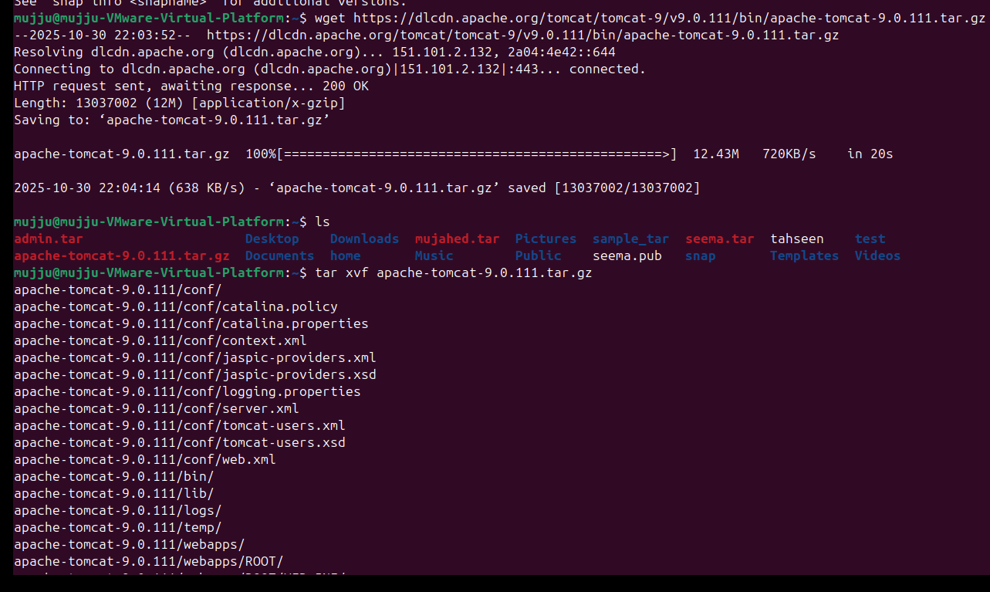

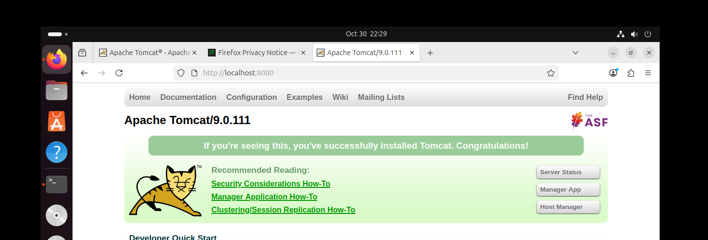

- create a service file for Apache Tomcat.(Should execute by using systemtctl command)
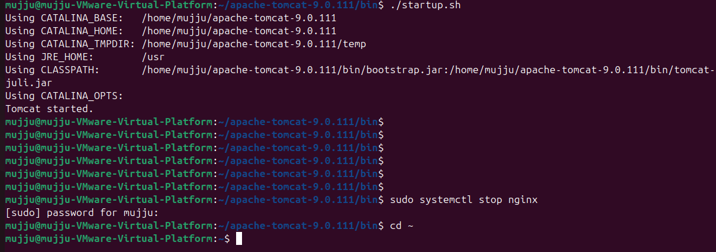

- Print specific columns from a delimited file.
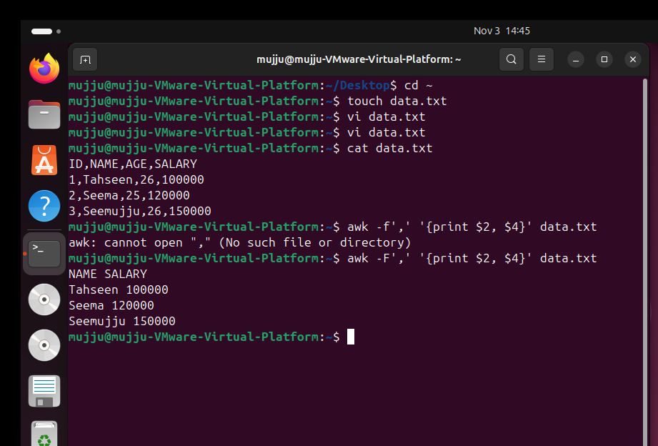

- Filter and print lines based on a specific pattern or condition.
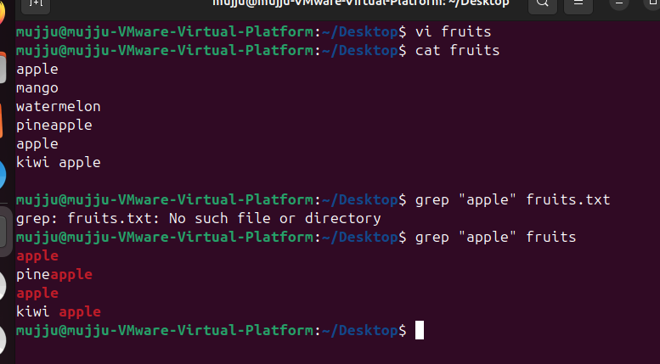
- Calculate and print the average, sum, or other statistics of a column.
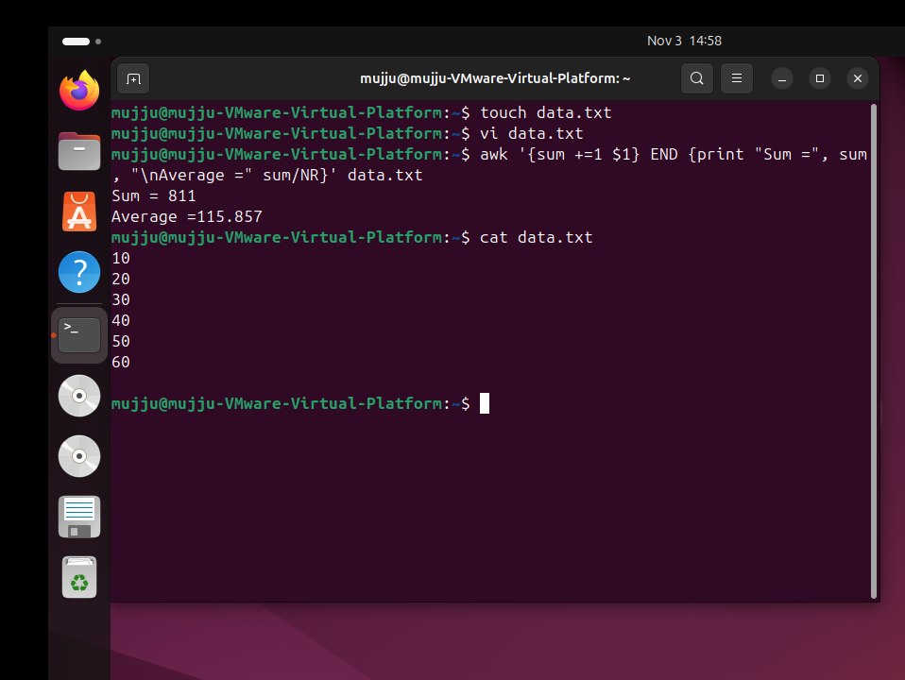

- Perform string manipulation, such as extracting substrings or changing case.
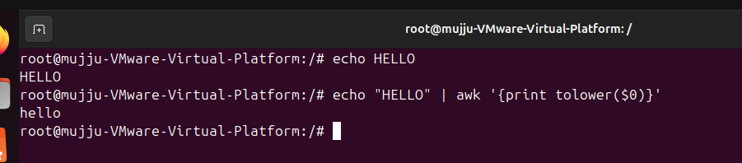

- Count the occurrences of a specific pattern in a file.
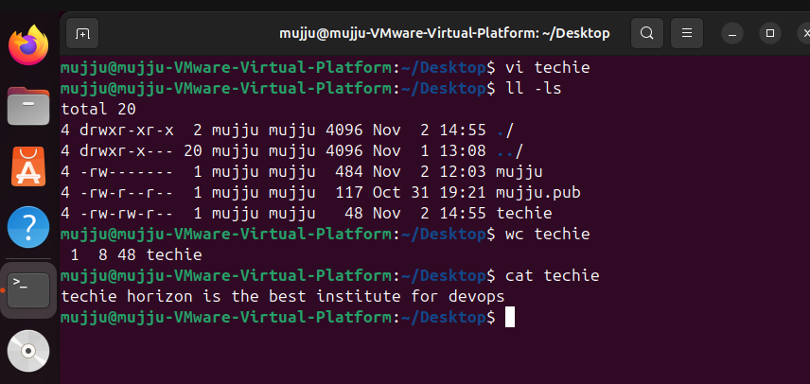

- Sort lines based on a specific field or column.
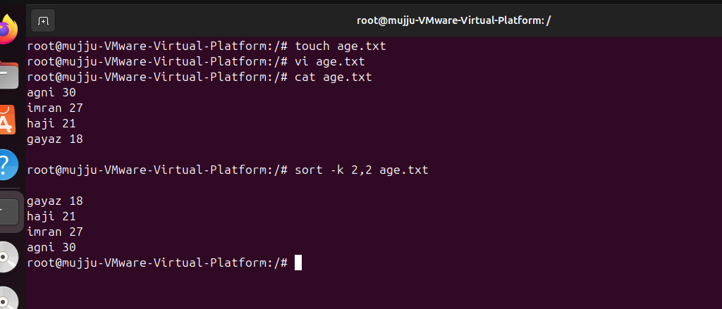

- Merge multiple files based on a common field or column.
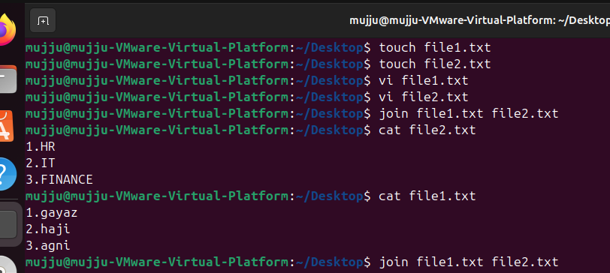
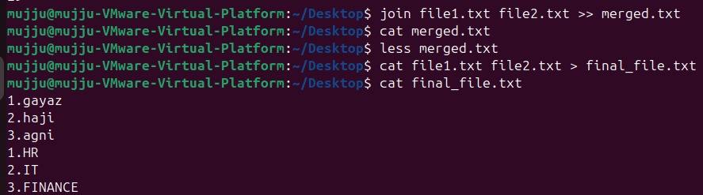

- Substitute text in a file using search and replace.


- Delete specific lines based on a pattern or line number.
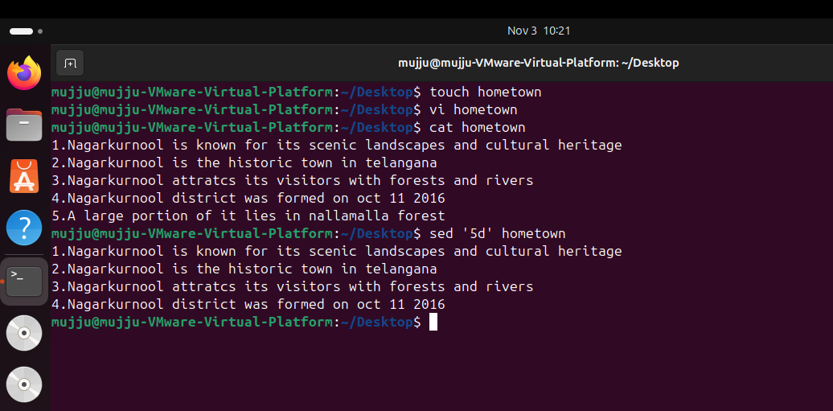
- Append or insert text before or after a specific pattern or line.

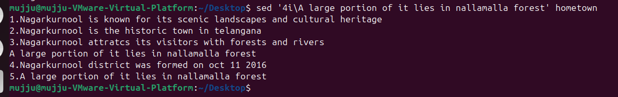

- Print only specific lines from a file.
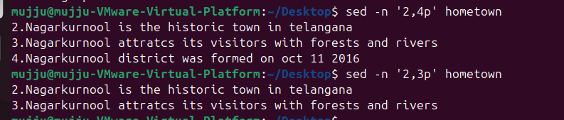

- Copy file from linux to windows machine
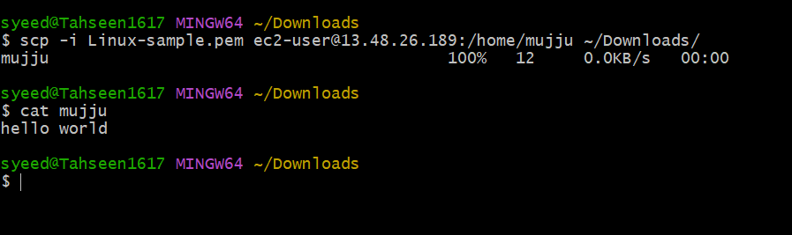



- 5 use cases for AWK and 5 use cases for sed

Use Case | Description | Example
1. Print specific columns | Extract certain fields from a text file or CSV | awk '{print $1, $3}' file.txt prints the 1st and 3rd columns
2. Calculate sum, average, or statistics | Quickly compute totals or averages of numeric columns | awk '{sum+=$2} END{print sum, sum/NR}' data.txt
3. Filter rows based on conditions | Only process lines that meet certain criteria | awk '$3 > 80 {print $1, $3}' marks.txt prints rows where 3rd column > 80
4. Use custom field separators | Handle files with delimiters other than spaces (comma, tab, etc.) | awk -F',' '{print $2, $4}' data.csv extracts fields from a CSV
5. Modify or reformat lines  5 use cases for sed : | Add line numbers, change field order, or create reports | awk '{print NR, $0}' file.txt adds line numbers before each line
Use Case | Description | Example
1. Find and replace text | Replace words or patterns globally | sed 's/apple/orange/g' file.txt replaces all occurrences of "apple" with "orange"
2. Delete specific lines | Remove lines by number or pattern | sed '3d' file.txt deletes line 3; sed '/error/d' logfile.txt deletes lines containing "error"
3. Print specific lines or ranges | Extract a range of lines for inspection | sed -n '5,10p' file.txt prints lines 5 to 10
4. Insert or append lines | Add content before or after specific lines | sed '2i\Inserted line' file.txt inserts before line 2; 2a\Appended line appends after
5. Use regex for complex replacements | Replace patterns using regular expressions | sed 's/[0-9]\+/[NUMBER]/g' data.txt replaces all numbers with [NUMBER]

